Rungta International Skills University, Bhilai C.G.

Lecture-wise Content Preparation Template

Subject Details
Program | B.TECH 1ST SEM (SoCE)
Subject Name | New Age Life Skills – IT Skills
Subject Code | RU-100-17-0002
Semester | 1st
Unit No. | 1
Faculty(ies) Name | FIRDAUSH JAHAN

Lecture Details (Repeat for Each Lecture)
Lecture No. | 3
Duration | 1 hrs
Planned Date

1. Learning Objectives (LOs)

Understand the concept and working of the IPO (Input-Process-Output) cycle.

Identify and differentiate between various types of storage devices.

Recognize common ports and connectors used in computer systems.

Apply knowledge of IPO cycle, storage devices, and ports in practical computing situations.

Prerequisite Knowledge

- Basic computer parts
- Input and output devices
- Simple data flow understanding
3. Content to be Delivered
IPO Cycle (Input–Process–Output):

The IPO Cycle is a fundamental concept that explains how a computer system works:

The Internal Flow of the IPO Cycle
1. Input
This is the stage where the computer receives raw data or instructions from a user or another device. The data is entered into the system through input devices.
- Internal Working: When you type on a keyboard, click a mouse, or use a scanner, the input device converts your action into a digital signal (binary code—0s and 1s) that the computer can understand. This digital data is then sent to the computer's Central Processing Unit (CPU) via a data bus. The data is temporarily stored in the computer's Random Access Memory (RAM) so the CPU can access it quickly.
2. Process
This is the "thinking" stage where the computer's CPU works on the input data according to the given instructions. It's where all the calculations and logical operations happen.
- Internal Working: The CPU fetches the instructions and data from RAM. It then uses its internal components:
  - Control Unit (CU): The CU is the "traffic cop" of the CPU. It fetches instructions, decodes them to understand what needs to be done, and then directs other parts of the CPU to perform the task.
  - Arithmetic Logic Unit (ALU): The ALU performs all the mathematical calculations (addition, subtraction, etc.) and logical comparisons (e.g., is A equal to B?).
  - Once the processing is complete, the results are sent back to the RAM, ready to be displayed or saved.
3. Output
This is the final stage where the processed data (now meaningful information) is presented to the user. This is done through output devices.
- Internal Working: The CPU sends the processed data from RAM to an output device. The output device then converts the digital signals back into a human-readable format. For example, a monitor's graphics card converts the digital signals into an image, a speaker converts them into sound waves, or a printer converts them into a physical document.

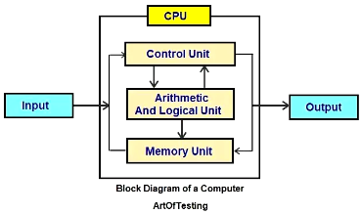

Example 1: Typing in a calculator app

Input: Numbers and operation (+, –, etc.)

Process: CPU performs the calculation

Output: Result is displayed on screen

Example 2: Withdrawing Money from an ATM

Input: You insert your debit card and enter your PIN and the amount you wish to withdraw.

Process: The ATM's system verifies your PIN, checks your account balance, and communicates with the bank's server to process the transaction and deduct the requested amount from your account.

Output: The ATM dispenses the cash and a transaction receipt is printed.

Storage Devices:

Storage devices are used to store data and instructions, either temporarily or permanently. They are categorized into:

Primary Storage (Main Memory):

There are two main categories of primary storage: RAM and ROM.

Random Access Memory (RAM)

RAM is the most common type of primary storage. It's the "working memory" of your computer. When you open a program or a file, the computer loads it from your hard drive into RAM.

This allows the CPU to access the data much faster than it could from the hard drive, making the program responsive. The more RAM a computer has, the more programs and data it can handle simultaneously, which improves multitasking and overall performance.

DRAM (Dynamic RAM): The most widely used type of RAM in modern computers. It's affordable but needs to be constantly refreshed with an electrical charge to retain data.

SRAM (Static RAM): Faster and more expensive than DRAM. It doesn't need to be refreshed and is typically used for cache memory, a smaller, faster form of memory located even closer to the CPU.

Read-Only Memory (ROM)

ROM is a type of non-volatile primary storage. This means the data on it is permanent and remains even when the power is off. It's used to store critical, permanent instructions that are needed to start the computer.

The most common example is the BIOS or UEFI, which contains the instructions to boot up the operating system and check the hardware. Unlike RAM, the data on ROM is generally not meant to be modified.

- Programmable ROM (PROM)
A PROM chip starts out as a blank slate. Unlike MROM, it's manufactured with all of its memory bits set to a certain state (e.g., all 1s).
The user can then "burn" or "program" the chip once using a special device called a PROM programmer.
This process uses high voltage to permanently break tiny internal fuses, setting the bits to 0s. Once programmed, the data cannot be erased or reprogrammed. This gave manufacturers flexibility to program chips after production.

- Erasable Programmable ROM (EPROM)
EPROM was the first step toward a reprogrammable ROM. It has a tiny quartz window on the top of the chip that exposes the silicon die. Data is programmed onto the chip using an EPROM programmer, which stores an electrical charge in its memory cells. The stored data can be completely erased by exposing the chip to intense ultraviolet (UV) light for a specific period (typically 10-20 minutes). The UV light dissipates the electrical charge, clearing the memory so it can be reprogrammed. EPROM was common in older PCs for the BIOS, as it allowed for firmware updates.

- Electrically Erasable Programmable ROM (EEPROM)
This type of ROM was a major advancement because it could be erased and reprogrammed electrically without needing to be removed from the circuit or exposed to UV light. EEPROM allows for byte-level erasure, meaning you can change individual bytes of data without erasing the entire chip. This makes it much more flexible and convenient for applications that require occasional data updates, such as storing configuration settings in a smart card or a microcontroller. However, EEPROM is typically slower and has a limited number of erase/rewrite cycles compared to flash memory.

Secondary Storage (Permanent Memory):

Hard disk drive (HDD)
- A hard disk drive is the storage built into your computer. If you’ve been using that device, you’ve likely already stored some files on its HDD.
- Being the more traditional type of storage, a hard disk uses spinning disks to read and write data. An HDD is generally suitable for extensive storage needs like TV recorders and servers.
- While it may not be as fast or as reliable as more modern solutions, an HDD has the benefit of being cheaper and typically much larger in storage capacity.

Solid-state drive (SSD)
- Solid-state technology is, in many ways, the evolution of the traditional HDD.
- Rather than spinning disks that are prone to malfunctioning, a solid-state drive uses flash memory for faster, more reliable performance without moving parts.
- This means an SSD can run faster and is less likely to break than an HDD. They are typically found in modern PCs, smartphones, and tablets.
- While they are faster and more reliable, this comes at a cost. Compared to an HDD, an SSD will be more expensive and will generally have less storage space available than an HDD.

Ports and Connectors:
Port: This is the opening on the computer itself. It's the gateway for data, video, and/or power to enter or leave the system. It's a key part of the computer's hardware, often a fixed component on the motherboard or a dedicated expansion card.
Connector: This is the part of the cable that's physically designed to fit into a specific port. Connectors have pins or contacts that align with the corresponding points inside the port to establish a connection.
1. USB (Universal Serial Bus)
Real-life Example:
- Port: The rectangular slot on your laptop or desktop computer is a USB port.
- Connector: The end of the cable you use to charge your phone, connect a printer, or plug in a mouse is a USB connector.
- USB-A: The classic, rectangular port found on most computers.
- USB-C: A newer, small, and reversible oval-shaped port. It’s highly versatile, supporting data transfer, video output (with "DisplayPort Alt Mode"), and power delivery.
- Micro-USB/Mini-USB: Smaller versions of USB-A, commonly found on older smartphones, tablets, and digital cameras.
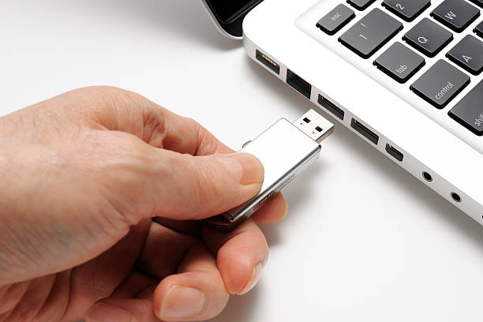

2. HDMI (High-Definition Multimedia Interface)
An HDMI (High-Definition Multimedia Interface) port is a proprietary digital interface used to transmit uncompressed high-definition video and multi-channel audio from a source device (like a computer, gaming console, or Blu-ray player) to a display device (a TV, monitor, or projector).
The primary advantage of HDMI is that it uses a single cable to carry both audio and video signals, which has simplified home entertainment systems and replaced older, separate analog connections like VGA and RCA cables.
Port: The trapezoidal slot on the back of your television, monitor, or projector.
Connector: The end of the cable connecting your Blu-ray player, gaming console (like a PlayStation or Xbox), or a laptop to the television.

- Single Cable for Everything: HDMI cables transmit both high-definition digital video and multi-channel digital audio in a single cable. This greatly reduces cable clutter and simplifies the setup process for home theater systems, gaming consoles, and computers.

- Superior Quality: Since HDMI transmits a pure digital signal, there is no loss or degradation of quality, unlike older analog connections like VGA. This results in a sharp, clear picture and crisp, high-fidelity sound.

- Wide Compatibility: HDMI has become the universal standard for digital multimedia connectivity. It's widely supported by almost all modern TVs, monitors, projectors, gaming consoles, and streaming devices, making it easy to connect a wide variety of electronics.

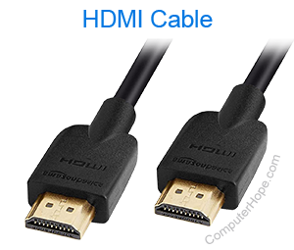

3. Ethernet
Port: The slightly wider port on the back of your computer, modem, or Wi-Fi router.
Connector: The end of the network cable (often called an RJ45 cable) you use to connect your computer to the internet router.
A wired Ethernet connection offers several key advantages:
- Speed: Ethernet connections are often significantly faster than Wi-Fi, with speeds ranging from 100 Mbps to multiple gigabits per second (Gbps) depending on the hardware and cable category (e.g., Cat 5e, Cat 6, Cat 7). This is ideal for activities that require high bandwidth, such as 4K video streaming, online gaming, and large file transfers.
- Stability: A wired connection is not subject to the same interference issues as Wi-Fi. It provides a consistent, low-latency connection, which is crucial for real-time applications where a stable signal is essential.
- Security: Data transmitted over an Ethernet cable is more secure than a wireless signal, which can be intercepted over the air. An Ethernet connection requires physical access to the network, making it a more secure option for sensitive data.

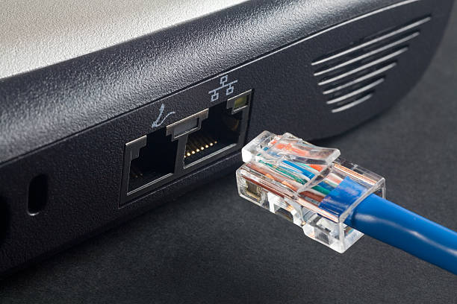

4. Audio Jacks (3.5mm)
Port: The small circular hole on the side of your smartphone, laptop, or music player.
Connector: The end of the cable on your headphones or speakers that you plug into the device.
The small, round port found on virtually all computers, laptops, and smartphones (though some newer smartphones have removed it). On a desktop, you'll often see a set of color-coded jacks:
- Green: Main stereo output for headphones or speakers.
- Pink: Microphone input.
- Blue: Line-in for connecting external audio sources like a CD player.

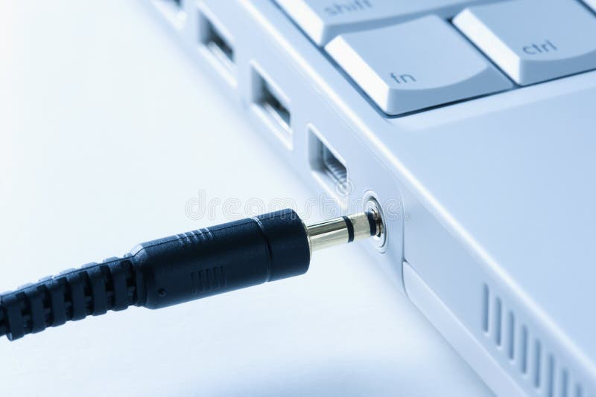

5. VGA (Video Graphics Array)
Port: A trapezoidal port with 15 holes, often found on older desktop computers and monitors.
Connector: The end of the cable that connects the computer to the monitor.
- Analog Signal: This is the defining characteristic of a VGA port. Unlike modern digital ports (like HDMI or DisplayPort) that transmit data as binary ones and zeros, VGA sends the video signal as varying electrical voltages. This analog nature can lead to signal degradation and lower quality, especially on longer cables.
- No Audio: A VGA port only carries video signals. To get sound, you need a separate cable, such as a 3.5mm audio jack, to connect your computer's audio output to speakers.

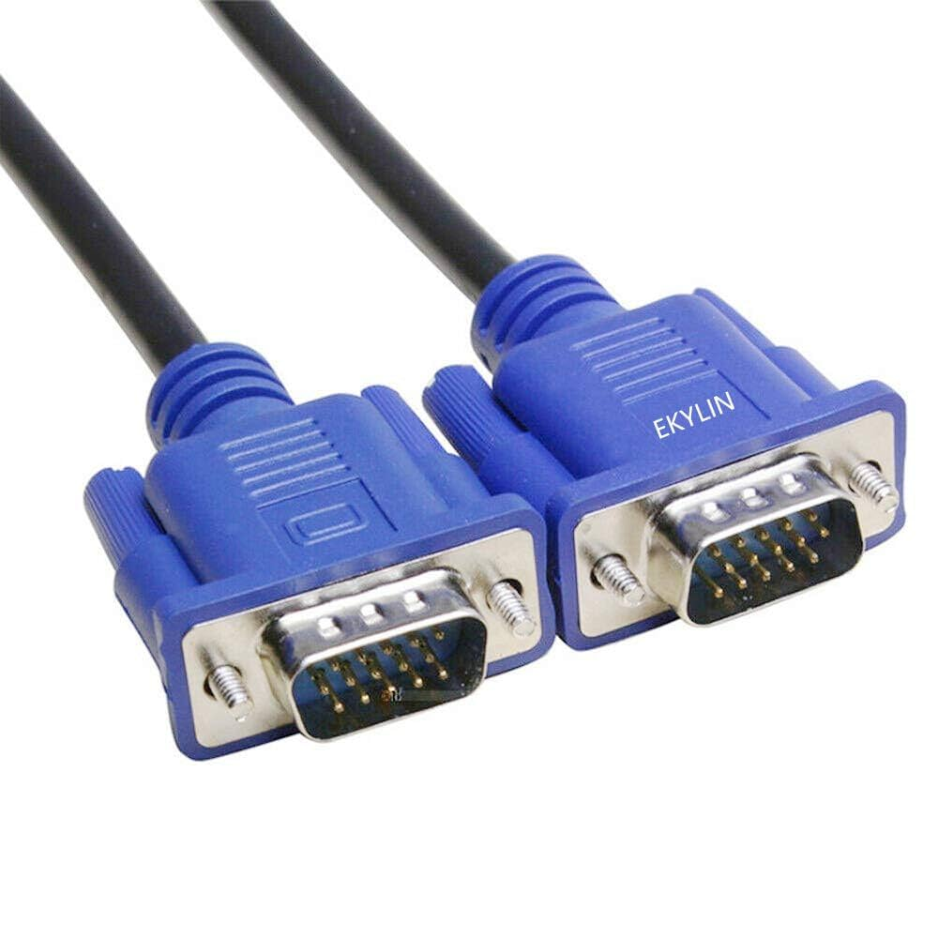

6. Power Connector

A power connector is an electrical connector used to deliver power to a device.

In the context of a personal computer, these connectors originate from the Power Supply Unit (PSU) and are designed to provide the correct voltage and current to different internal components.

They are "keyed" to fit into a specific port and prevent incorrect installation.

Port: The round or rectangular slot on the side of your laptop or the back of yourdesktop computer tower.

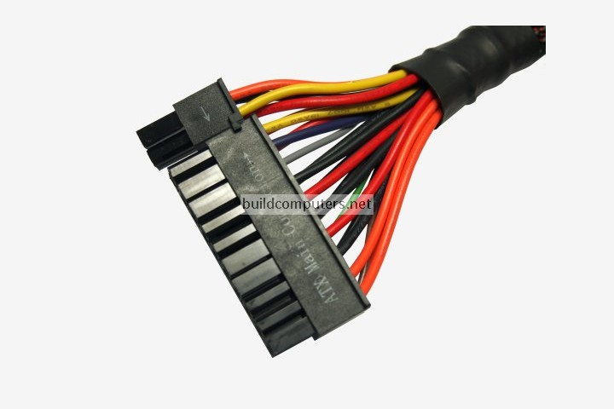
Connector: The end of the power cord that plugs into the device.

4. Case Study / Application / Use-case

IPO (Input-Process-Output) Cycle

Real-world Problem: A retail company is struggling with inventory management. They have a massive amount of raw sales data but can't turn it into actionable insights to optimize stock levels and reduce waste.

Case Study: The retail company implements a new point-of-sale (POS) and inventory management system.

Input: The system's input is the raw data from daily sales transactions (items sold, quantity, price), as well as incoming shipments and returns. This data is collected from the POS terminals, barcode scanners, and manual entries.

Process: The central processing unit (CPU) of the system takes this raw data and performs a series of calculations and manipulations. It processes the sales data to calculate daily revenue, tracks inventory levels by subtracting sold items and adding new stock, and identifies trends in popular products. It might also use algorithms to forecast future demand based on historical data and seasonal changes.

Output: The system generates various outputs that are useful to different stakeholders. Store managers get real-time dashboards showing current stock levels and alerts for low-stock items. The purchasing department receives reports on which products to reorder and in what quantities. The finance team gets summarized reports on revenue and profitability. This output helps the company make informed decisions, preventing overstocking or stockouts.

Ports and Connectors

Ports and connectors are physical interfaces that allow devices to connect and communicate.

Real-world Problem: A large company has a diverse range of older and newer hardware, including laptops, projectors, and monitors. Employees often have trouble connecting to meeting room displays because of incompatible ports and connectors.

Case Study: A multinational corporation, "TechCorp," has conference rooms with older projectors that only have VGA ports, while many of their employees use modern laptops with only HDMI or USB-C ports. This leads to wasted time during meetings as employees search for the right adapters or struggle to get their presentations displayed.

The Problem: The core issue is the lack of standardized ports and connectors. The VGA port on the projector is an older standard for analog video, while the HDMI and USB-C ports on the laptops are newer standards for digital video and data. The physical design of the connectors is completely different, making them incompatible without an intermediary device.

The Solution: TechCorp solves this problem by installing docking stations or universal port hubs in each conference room. These hubs have multiple ports, including VGA, HDMI, and USB-C, and come with a single cable to connect to an employee's laptop. This ensures that any employee, regardless of their laptop's port type, can easily connect to the display.

5. Practice Problems related to this lecture
- What are the three main stages of the IPO cycle, and can you give one real-life example?
- Why are ports and connectors essential for using external devices with a computer?
- Explain the block diagram of a computer system?
- What is primary memory and secondary memory? Differentiate between them.
- Explain RAM and ROM with types.
- Explain I/O ports and connectors (USB, HDMI, VGA, Ethernet).

6. References

https://www.geeksforgeeks.org/techtips/types-of-computer-cables-and-ports/

